Nominal rates

Figure 1.

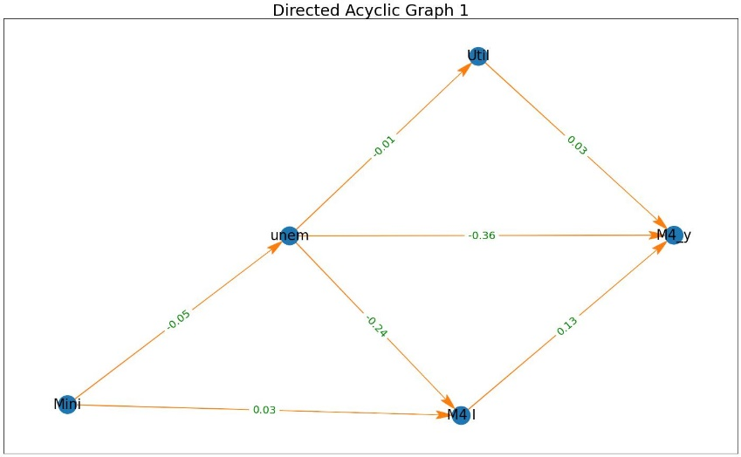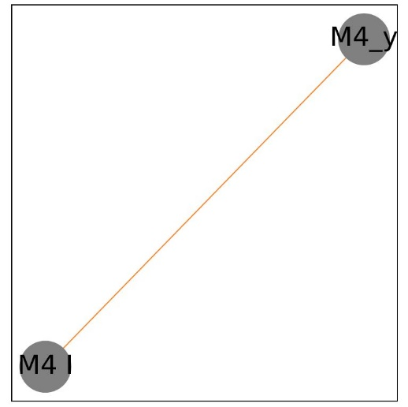

We start with the nominal rates with all variables included in the model. In figure 1 above, the link between money supply and interest rates appears to be consistent across all clusters using the nominal rates. This indicates that there is a causal relationship between them. An increase in the interest rate positively impacts the supply of money.

Nominal differenced rates

Figure 2

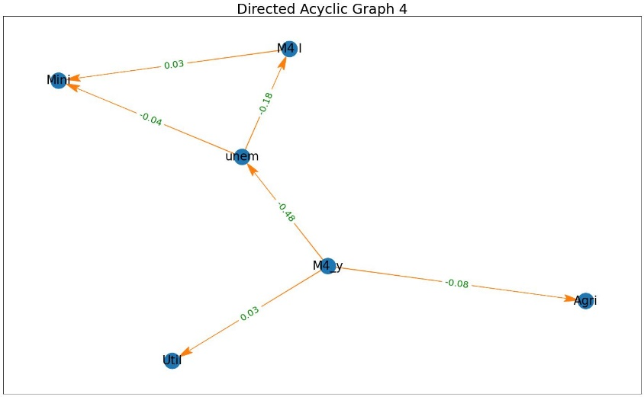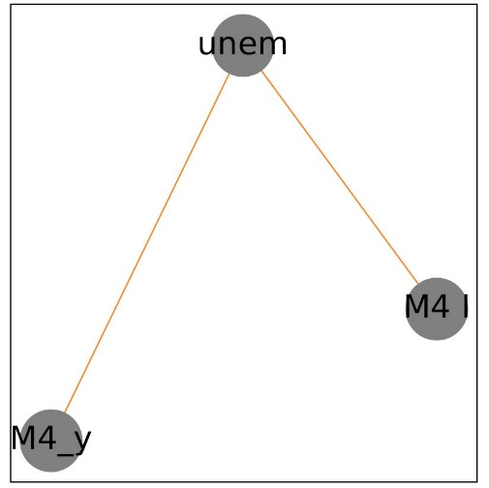

The plots in figure 2 represent the nominal differenced rates with all variables included in the model. According to the plot on the left, unemployment rates and money supply serve as an intermediary between the production industries. There is a direct relationship between unemployment and interest rates. The same can be observed for the money supply and unemployment. When incorporating clusters, where clusters were determined by unemployment, all counties had a similar pattern in terms of relationship. That is, the direct relationship between unemployment and money supply and interest rates.

Overall, clustering counties (by unemployment) indicates a consistent relationship between unemployment and money supply and interest rates.

Real rates

Figure 3

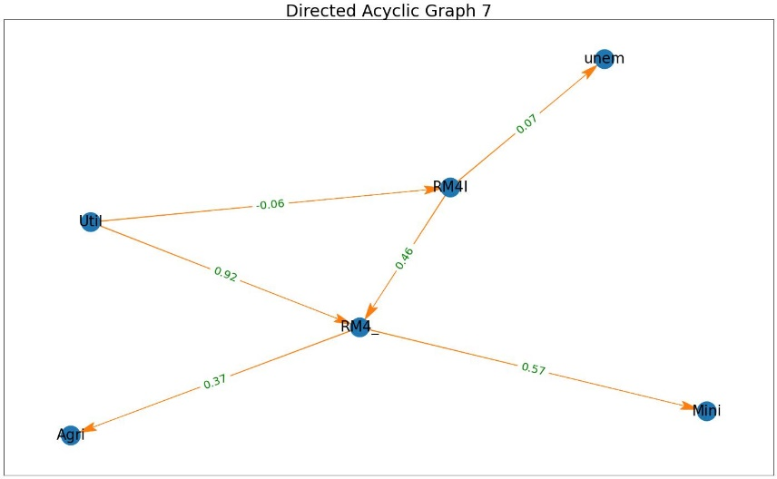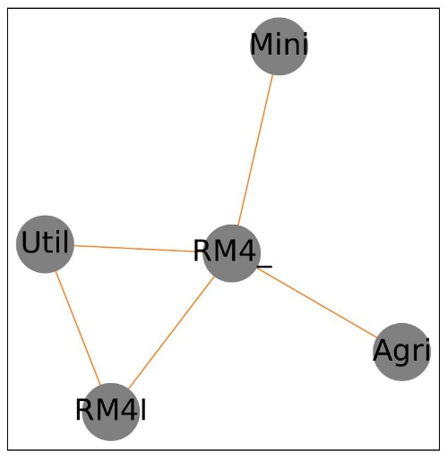

Now modeling with real rates and including all variables, we observe the following. Using the real rates, the real money supply and interest rates are observed to be intermediaries between the production variables and unemployment rates. The graph on the left of Figure 3 shows a direct causal relationship between real interest rates and unemployment, money supply and all production variables included in the model. They all have a positive relationship, while there was a negative correlation between utilities and real interest rates. The plot on the right illustrates the consistent relationships observed across all clusters. It is consistent with the results observed on the left-hand graph, except for the exclusion of unemployment. It appears that there isn’t a consistent relationship between real interest rates and unemployment rates across counties.

Figure 4

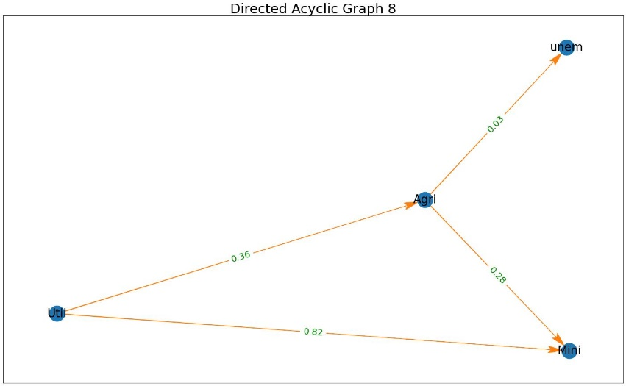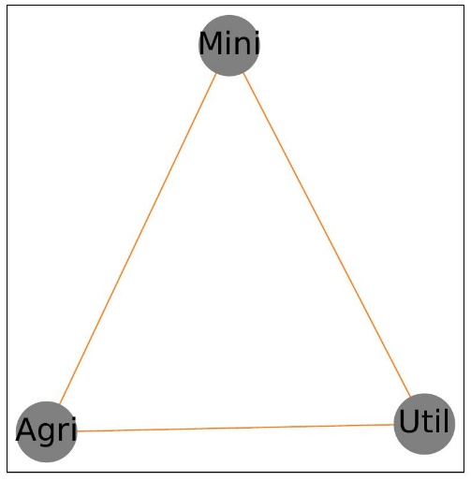

In the graphs above, the macroeconomic variables are excluded from the model to observe the behavior of the other variables (in this case the production variables and the unemployment rates). As can be observed in the graph on the left side of Figure 4, unemployment rates seem to be positively correlated with the Agricultural sector, which then acts as an intermediary for the other production sectors. They all have positive correlations as well. Including clusters as illustrated on the graph on the right side of Figure 4, there is a consistent relationship across counties amongst the production variables. Unemployment was observed to not have an impact consistently across all clusters.

Figure 5

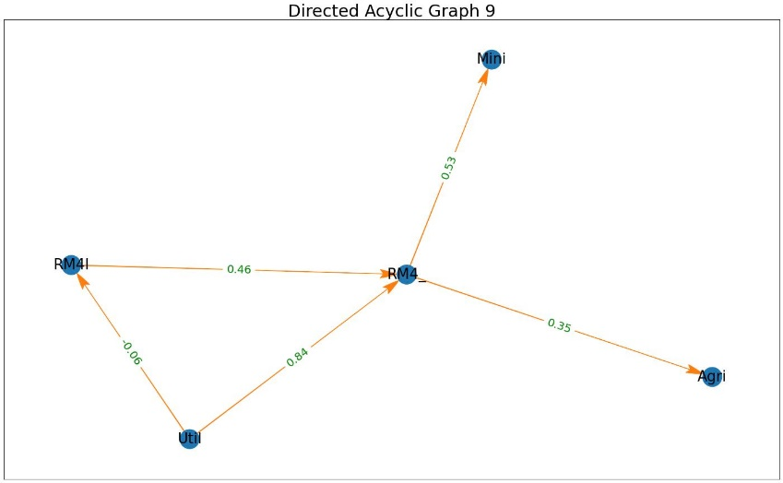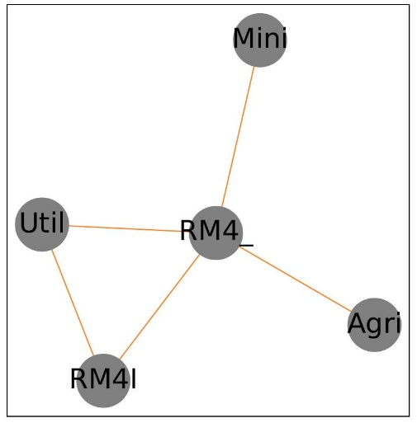

Finally, modeling with the real rates and excluding the unemployment rates, the macroeconomic variables (particularly real money supply) acted as an intermediary between all the production sectors in the economy. It also had positive correlations with all the production sectors. Real interest rates on the other hand also had a direct positive correlation with the real money supply, which could mean that an increase in the supply of real money to the production sectors of the economy would result to an increase in real interest rates. However, as can be noticed on the plot on the left-hand side of Figure 5, there is a negative and direct correlation between real interest rates and utilities. Which could mean that an increase in production in this sector could lead to a decrease in real interest rates but an increase in real money supply. When clusters are taken into account, all counties exhibit these same patterns/relationships as can be noticed on the right-hand side of Figure 5 above.

Real differenced rates

Figure 6

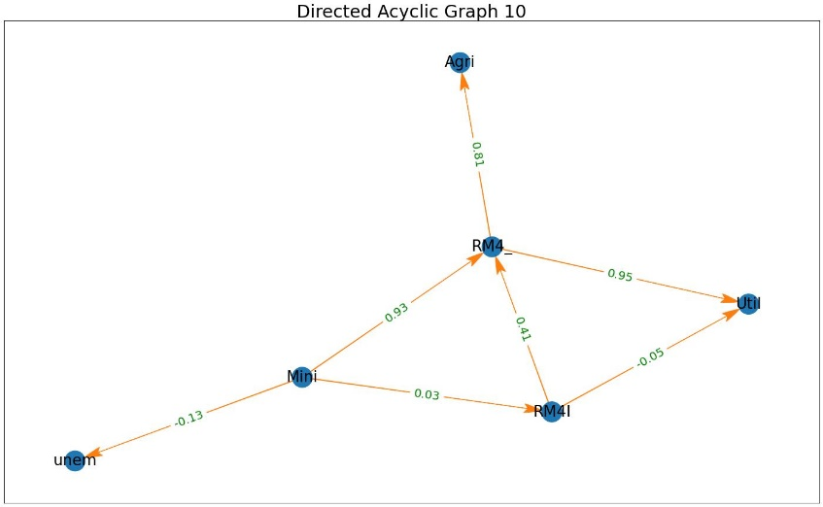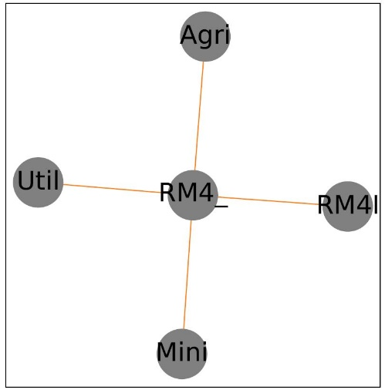

Next, we look at the differenced real rates (that is, percent change) and observe the patterns of relationships amongst the macroeconomic variables, labor variable and the production variables. Here we first take a look at all the variables. The real money supply still acts as an intermediary between the production variables, with an indirect relationship between the agricultural sector and the real interest rates. It can also be observed that unemployment rates and real money supply or real interest rates have indirect correlations with the intermediary being the Mining sector. The graph on the right-hand side of Figure 6 shows consistent relationships like that on the left-hand side. Which indicates that clustering the counties did not have a negative effect on the relationships. An exception being the absence of unemployment rates when clusters are taken into consideration. Meaning that some counties did not experience an impact of unemployment rates, whether positive or negative.

When the macroeconomic variables are excluded from the model, the mining sector appears to be the intermediary for every other sector. Including clusters also produces similar results across all counties. These can be observed in Figure 7 left- and right-hand sides.

Figure 7

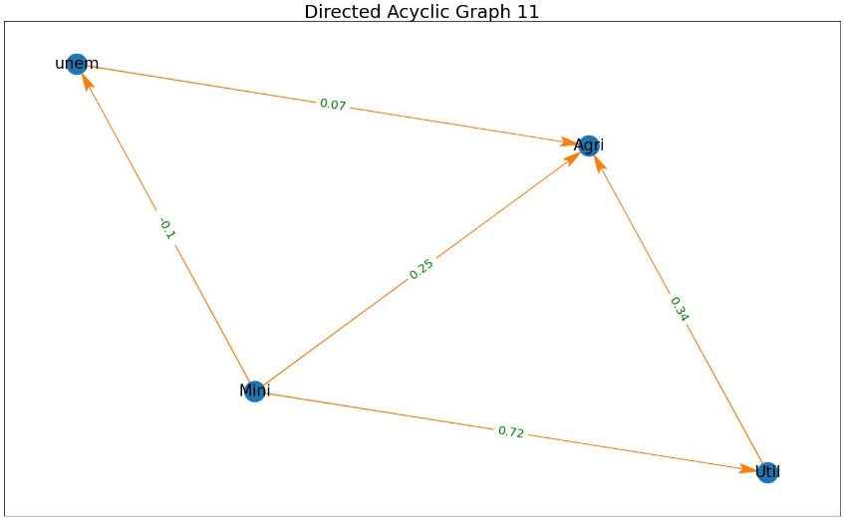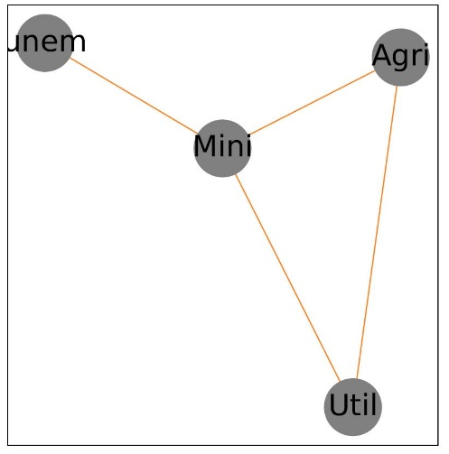

Figure 8

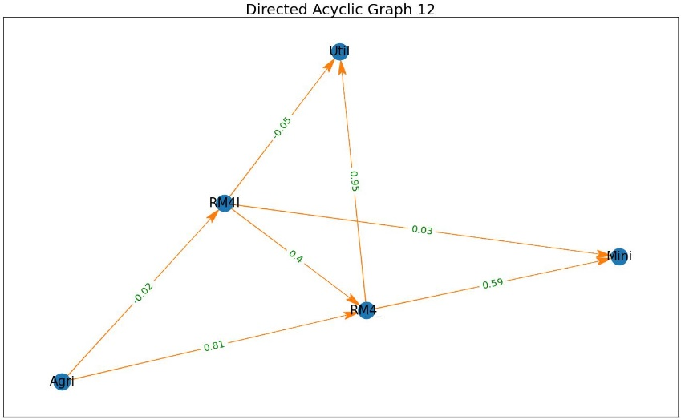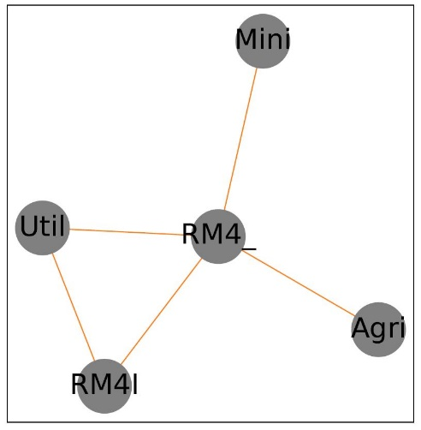

Finally, including the macroeconomic variables and excluding the unemployment rates in the model produced the plots observed in Figure 8 above. According to the model, the macroeconomic variables appear to be serving as intermediaries between all production variables. The same can be observed when clusters are taken into consideration.

Overall, a consistent observation indicates that the macroeconomic variables play an important role in the production sector of an economy. A shock in these macroeconomic variables could result in a negative impact on the production of the economy. These results are also observed to be consistent when clusters are implemented.